**PIZZA SALES SQL QUERIES**

1. Find the total revenue.



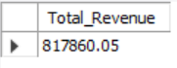

2. Find the average order value.



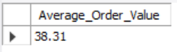

3. Find the total pizza’s sold.





4. Find the total orders placed.



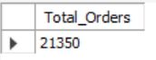

5. Find the average pizzas per order.



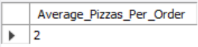

6. Find the trend of orders per weekdays.



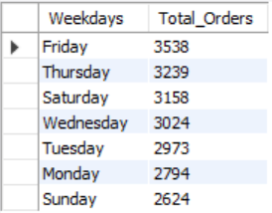

7. Find the trend of orders per month.



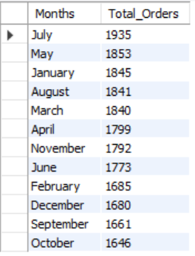

8. Find the percentage of sales by pizza category.



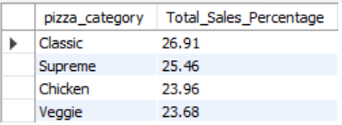

9. Find the percentage of sales by pizza size.



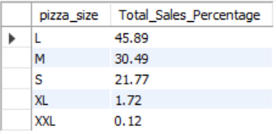

10. Find the total pizzas sold per category.



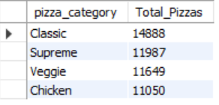

11. Find the Top 5 best sellers by quantity, revenue & orders.

Top 5 by Quantity:



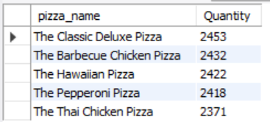

Top 5 by Revenue:



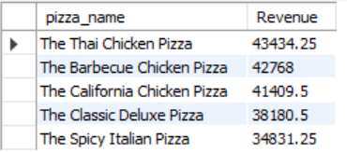

Top 5 by Orders:



